1. Install jdk (java development kit) by using the following command on the terminal. JDK must be installed before installing netbeans.

sudo apt-get update

sudo apt-get install openjdk-9-jdk

1. Netbeans Download

https://netbeans.org/downloads/

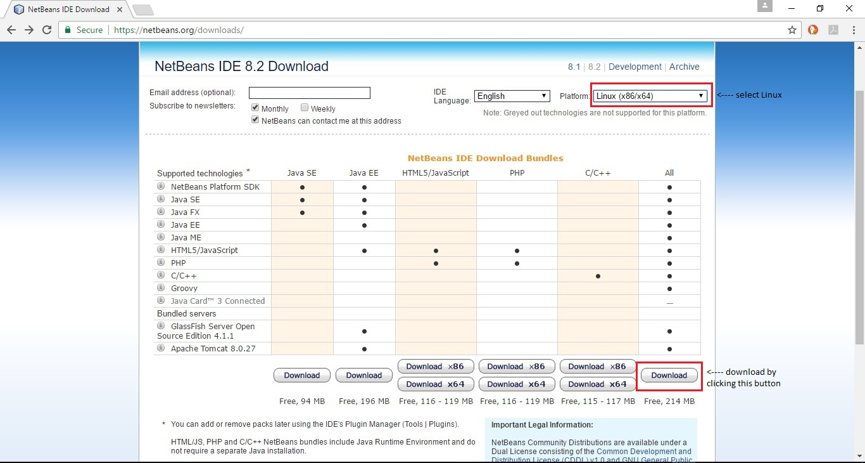

1. Netbeans Installation

The downloaded file will be placed in Downloads Folder. Run it by entering the following command on the terminal

sh ~/Downloads/netbeans-8.2-linux.sh

Now the GUI of netbeans installer will be displayed on the screen. Simply install netbeans now.